WGU Evaluations.

The screenshot below shows the reports chart working, as more appointments are added to more months, those months are dynamically populated with the corresponding amount of appointments.

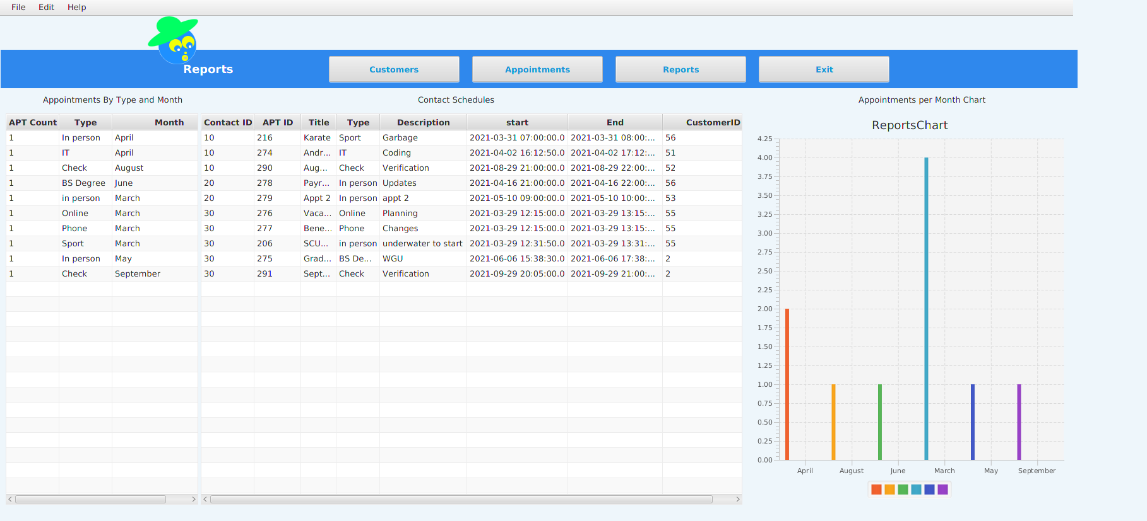

- The date now shows in local time for all table-views

- Added labels to assist with EST business times in addition to the EST checks at the time of data entry

- Upcoming appointments has also been address since the local time discrepancy was fixed, this of course can only be tested 15 minutes before the start of EST business hours as no appointments can be scheduled before that time

- Also the activity.txt file was renamed to the proper login_activity.txt name

And here the time discrepancies have been addressed, cannot add overlapping appointments as shown below:

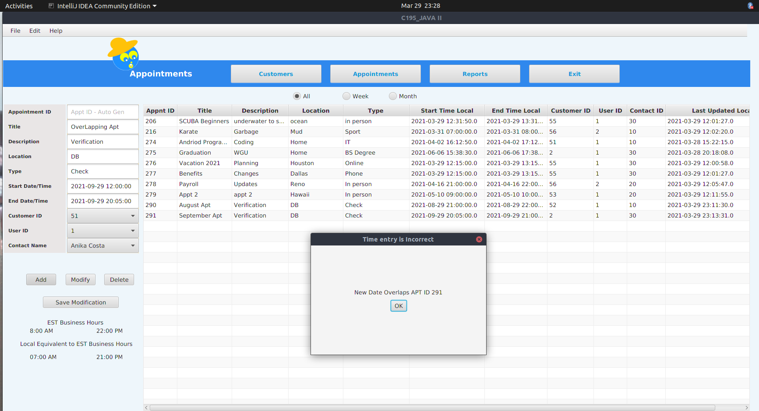

Same with modifications as seen below:

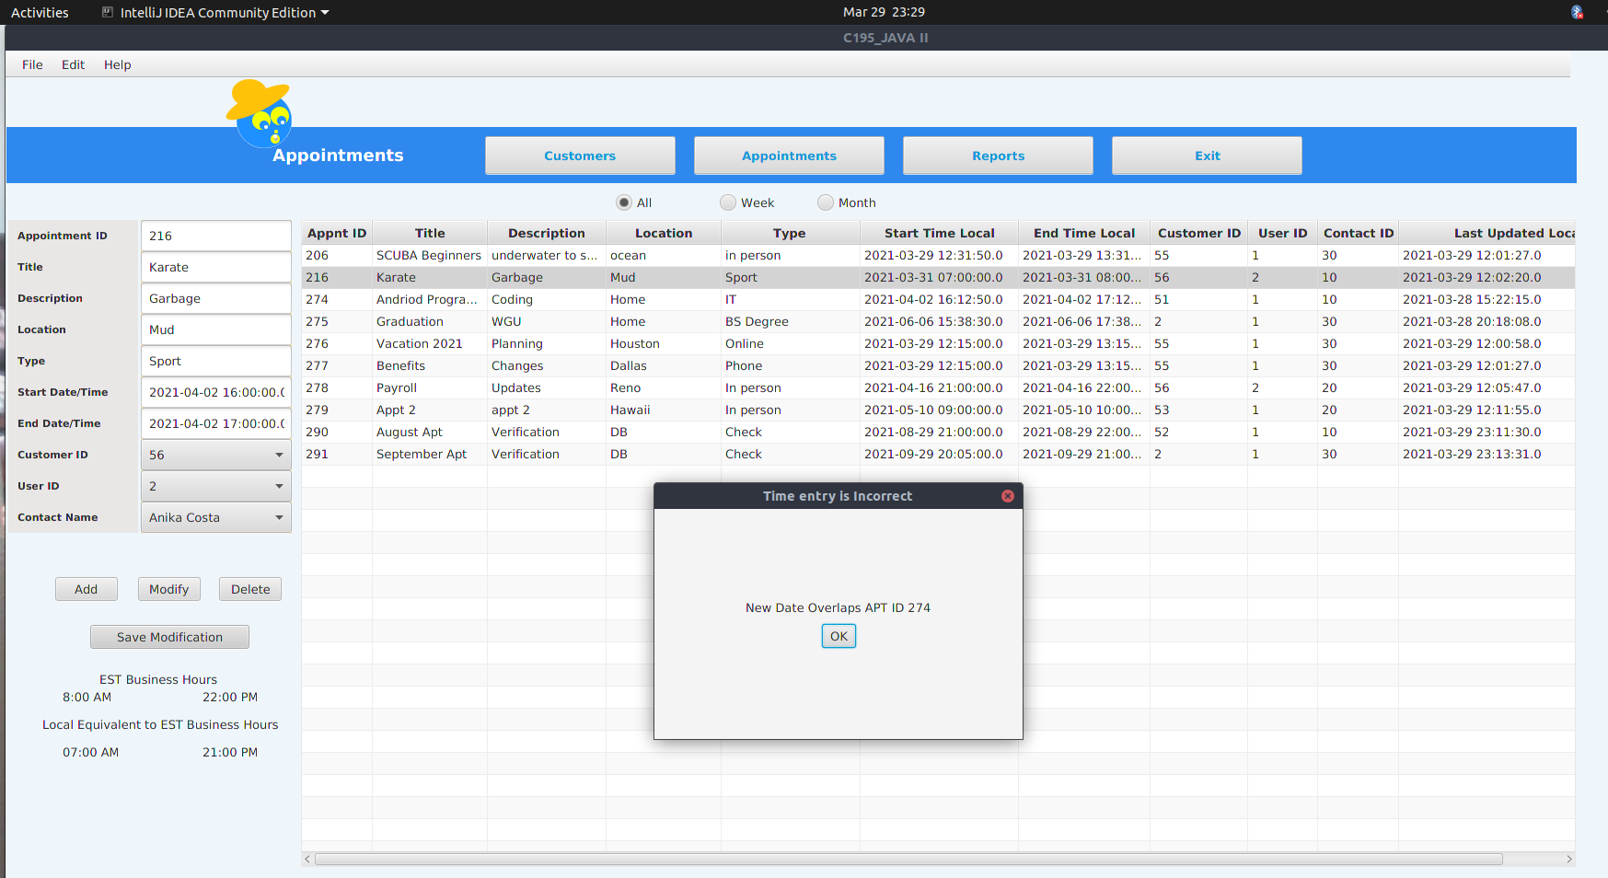

Thank you,

v/r

Rob Bradbury

Student ID:  001467937

[rbradb5@my.wgu.edu](mailto:rbradb5@my.wgu.edu)

(503)-984-7518

Mentor: Natasha Kelly-Abner